**Locators Practice**

1.

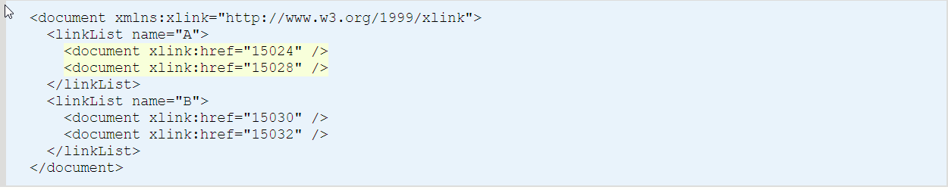

Select all document elements below the node “linkList” with the name A.

2.

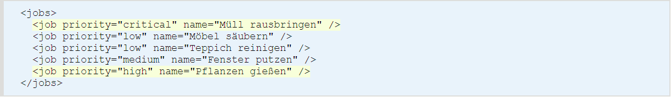

Select all jobs with a priority corresponding to the value “critical” or “high”.

3.

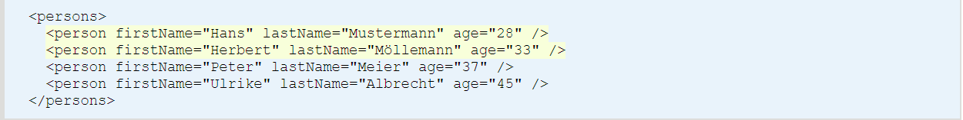

Select all persons aged less than 35 years.

4.



Select all persons whose first name begins with the letter H.

5.



Select the first three person elements.

6.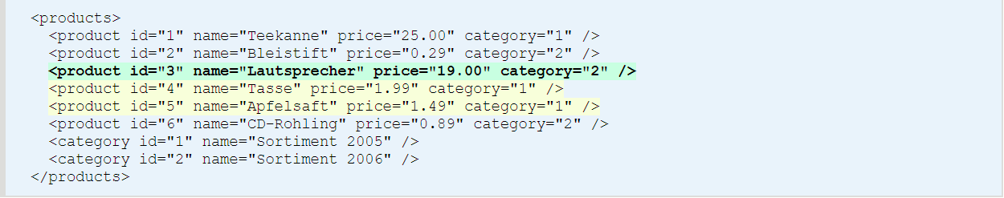

Select the following product siblings, which contain the value 1 as a category, relatively from their current node.

7.

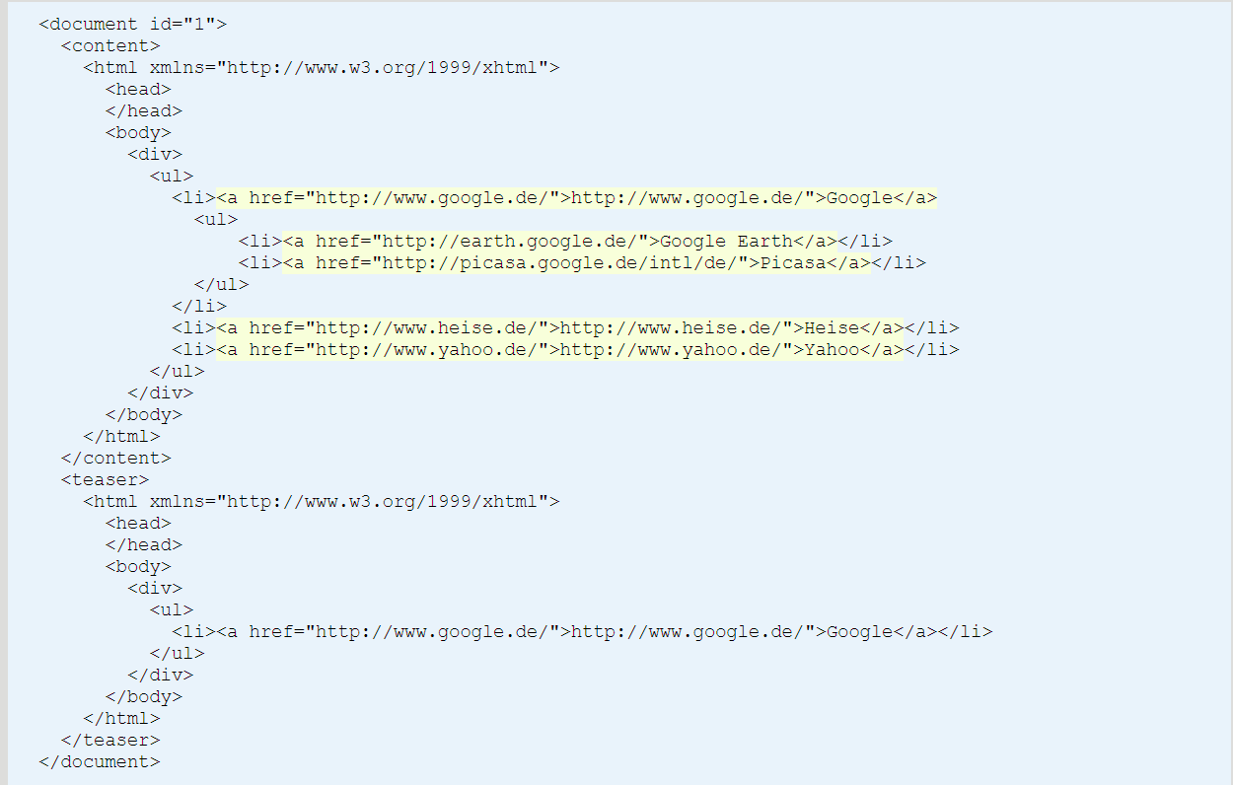

Collect all links in the document (HTML elements of type a, which are attached to the namespace http://www.w3.org/1999/xhtml) below the elements document/content.

8.

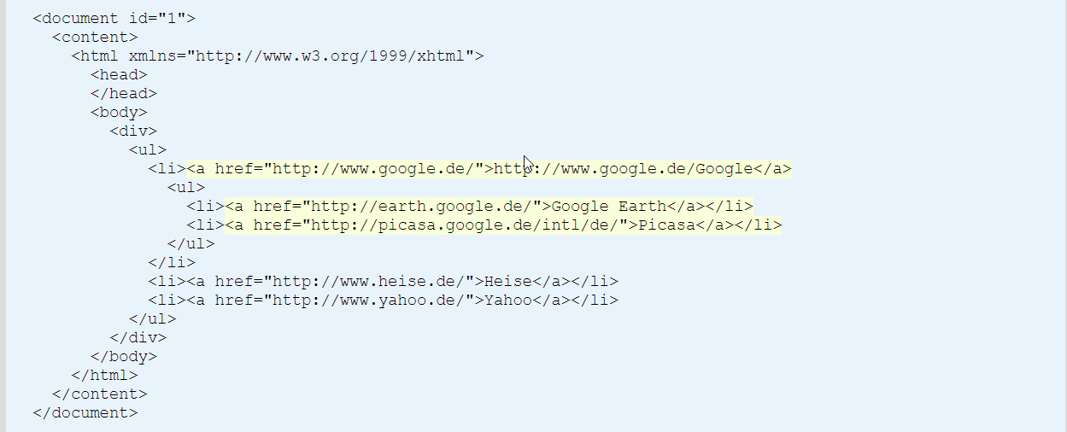

Collect all links in the document (HTML elements of type a, which are attached to the namespace http://www.w3.org/1999/xhtml) which refer to a Google service. The existence of the text “google” within the href-attribute decides whether a Google service is concerned. For the XPath expression, the prefix x is available for the namespace “http://www.w3.org/1999/xhtml”.

9.

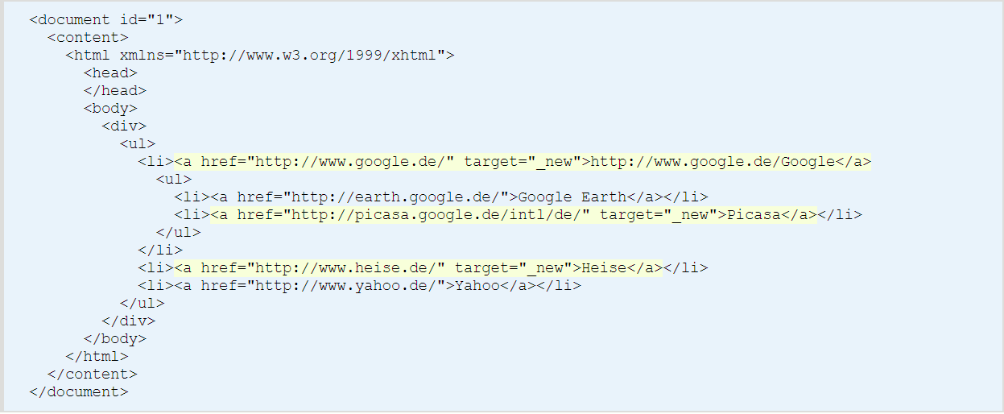

Collect all links in the document (XHTML elements of type a, which are attached to the namespace “http://www.w3.org/1999/xhtml”) which are opened in a new window (attribute "target=_new").

10.

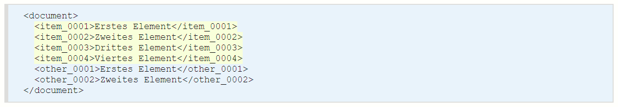

Select all elements with the name beginning with »item«.

11.

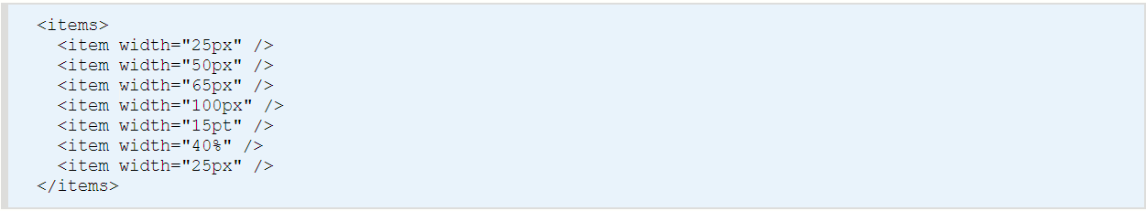

Output all item-elements that are specified in “px”.

12.

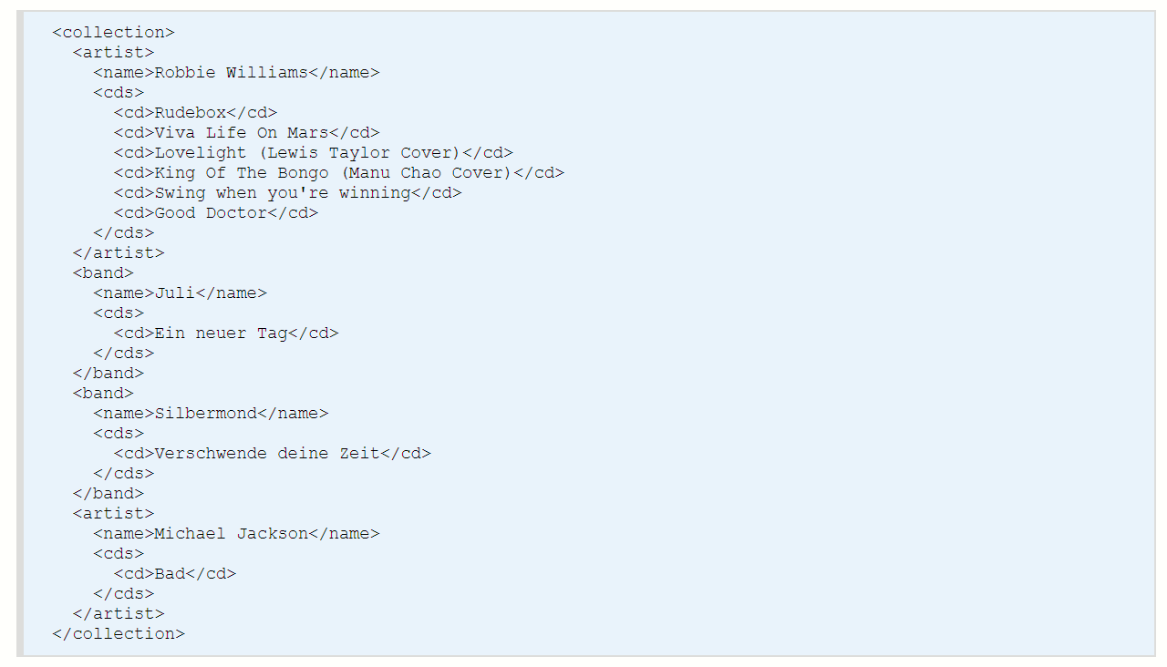

Select all band or artist elements containing only one CD.

13.

<https://docs.dhtmlx.com/suite/samples/grid/01_init/01_basic.html>

1. Find the population of France.
2. Find the density of Germany